How to run MR Lab Demos
Michael Mihocic
Last update: 02.09.2025

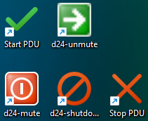
Switch on Hardware
- switch on PC in rack
- switch on monitor
- log on on PC as user “MRLab” (password required)
- on Windows desktop: run “Start PDU” to switch on all amplifiers and devices
- wait a few seconds until all of them are booted up
- on Windows desktop: run “d24-unmute” to unmute all amplifiers
  - note: unmuting the amplifiers them will double their power consumption
  - using the script “d24-mute” will soft mute them again

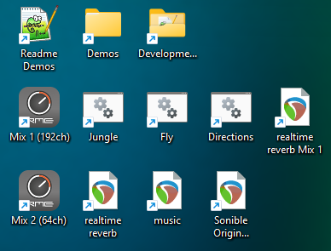
Run Demos
- make sure that all amplifiers are unmuted (no red icon on the top left edge of their screen)
- on Windows desktop:
  - “Mix 1 (192ch)” loads the configuration for all 192 channels, used by some demos
  - “Mix 2 (64ch)” loads the configuration for 64 channels, used by some demos
  - when changing Mixes, there might be a prompt asking to discard manual changes → confirm the dialogue

List of Demos Mix 1
load “Mix 1 (192ch)”
- Jungle: birds, rain and thunder
  - double click link to batch file
  - press green button to start demo
  - optional: use light green buttons to start delayed, or to enable loop
  - orange fader (left) controls volume
  - demo can be combined with demo “realtime reverb Mix 1”
  - press “stop” or close all Pd windows to stop demo
- Fly: a fly circling around the room
  - double click link to batch file
  - press green button to start demo
  - optional: use light green buttons to start delayed, or to enable loop
  - orange fader (left) controls volume
  - demo can be combined with demo “realtime reverb Mix 1”
  - press “stop” or close all Pd windows to stop demo
- Directions: single directions, each played with 3s signals of pink noise
  - directions (azi, ele):
    - 0,0: North (long wall, directing entrance with glass door)
    - 90,0: West (short wall)
    - 180,0: South (long wall, opposite entrance)
    - 270,0 (short wall, directing LED wall)
    - 45,45 (elevation up)
    - 225,-45 (elevation down)
  - double click link to batch file
  - press green button to start demo
  - optional: use light green buttons to start delayed, or to enable loop
  - orange fader (left) controls volume
  - demo can be combined with demo “realtime reverb Mix 1”
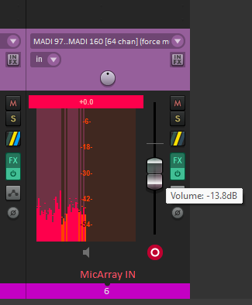
  - press “stop” or close all Pd windows to stop demo
- realtime reverb Mix 1
  - double click on link
  - demo starts automatically
  - warning: it might be necessary to lower the volume of “MicArray IN” to avoid feedback (see screenshot)
  - close Reaper to stop demo

List of Demos Mix 2
load “Mix 2 (64ch)”
- realtime reverb
  - double click on link
  - demo starts automatically
  - warning: it might be necessary to lower the volume of “MicArray IN” to avoid feedback (see screenshot)
  - close Reaper to stop demo
- music
  - double click on link
  - hit “Space” button to launch the demo
  - hit “Space” again, or close Reaper to stop demo
- Sonible Original
  - kept as backup; this is the state we received the demo from Sonible

Switch off Hardware
- on Windows desktop: run “d24-shotdown” to shutdown amplifiers
- wait a few seconds until all of the amplifiers are shut down
- on Windows desktop: run “Stop PDU” to switch off amplifiers (and save a lot of power…)
- shut down PC
- switch off monitor

